Mendon-Upton Regional School District
Guide to Educator Evaluation

2014-2015
School Year

Table of Contents

Overview | p. 3
Continuous Cycle | p. 4
Educator Plans | p. 5
Timeline | pp. 6-7
Teacher Rubric at a Glance | p. 8
SMART Goals | pp. 9-11
Review Meetings | p. 12
How to Use TeachPoint | pp.12-19
Evidence | pp. 20-21
High Leverage Elements | pp. 22-25

Overview
How is the new Evaluation System Better?
Educators will:
- Be active, rather than passive participants in their own evaluation
- Use rubrics that offer a specific detail of practice at four levels of performance
- Consider team goals and focus on true collaboration
- Compile and present evidence detailing their progress
- Receive more frequent feedback from their evaluators throughout the year

Step 1: Self Assessment
- Every educator uses a rubric to self-assess their instructional and professional practices against the Performance Standards
- The self-assessment form is completed and used to develop two SMART Goals:
  - Student learning goal
  - Professional practice goal

Step 2: Analysis, Goal Setting, and Plan Development
- Educators share self-assessments and proposed goals with evaluators
- Educators and evaluator develop educator plan, including activities and supports to drive improvement and progress toward goal attainment
- Every educator must establish two goals:
1. One focused on student learning
2. One focused on professional practice
- They should use the SMART Goal format:
  - Specific and Strategic
  - Measurable
  - Action Oriented
  - Rigorous, Realistic, Results-Focused
  - Timed and Tracked
Step 3: Plan Implementation
- Educators pursue the action plans of their goals and collect evidence
- Evaluators support educators through observations, meetings and providing feedback on progress and improvement

Step 4: Formative Assessment/Evaluation
- Educator submits collected evidence on progress of goals.
- Evaluator assesses educator progress toward attainment of goals

Step 5: Summative Evaluation
- Educator submits collected evidence and evaluator reviews and analyzes evidence
- Evaluator issues performance rating on each standard, as well as an overall rating

2014-2015 Continuous Cycle

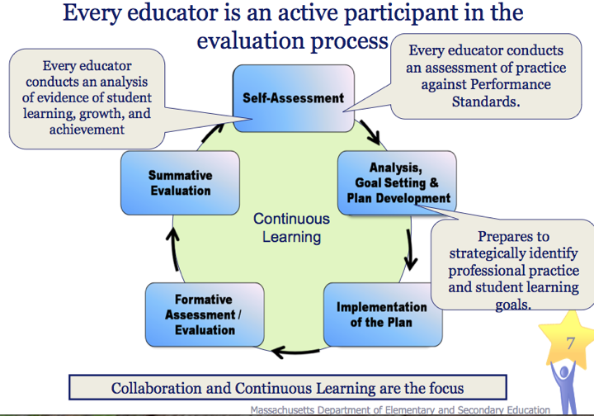

Educator Plans

Developing Educator Plan | Educators with Non-Professional Teaching Status
Self-Directed Growth Plan | For experienced educators rated Proficient or Exemplary on the last evaluation
Directed Growth Plan | For educators rated Needs Improvement on their last evaluation; up to one school year in length
Improvement Plan | For educators rated Unsatisfactory on their last evaluation; min of 30 calendar days up to one school year.

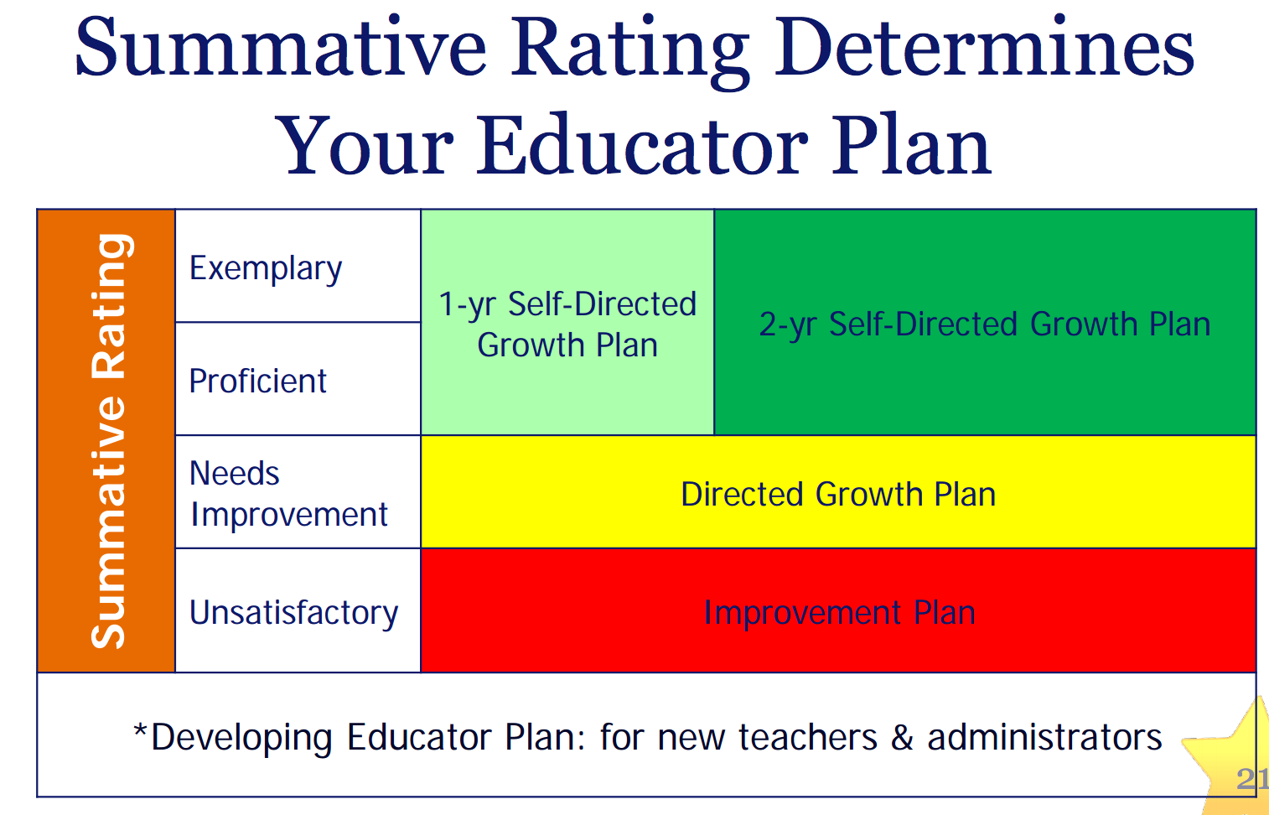
Educator Evaluation Timeline 2014-2105

Completed By | Activity
Walkthroughs | 1st Year Educators  - At least one announced observation  - At least 4 unannounced observations  Non-PTS Educators  - At least 4 unannounced observations  PTS Educators on 2 Year Cycle  - At least 3-6 unannounced observations per year of the cycle (over the course of the two years)
August 1 | All Educators  - Superintendent and Building Principals enumerate district and school goals to staff
September 15 | All Educators  - Superintendent, principal or designee meets with evaluators and educators to explain evaluation process (provide directions for getting forms, and overview of goal-setting and entire eval process)  - Educator submits a draft of proposed goals  1st-year Educators  - Evaluator meets with 1st-year Educators to assist in self-assessment and goal setting process  Two-Year Plan  - Educators in first year of two-year cycle submit a self-assessment as well as draft of proposed goals.
October 15 | All Educators  - Evaluator meets with Educators in teams or individually to review self-assessment, finalize goals and establish Educator Plans
November 1 | All Educators  - Evaluator completes Educator Plans. Educator signs within 5 days of receipt
November 15 | All Educators  - Evaluator should complete first observation of each Educator
January 15 | One-Year Plan  - Educators on a one-year plan submits evidence on parent outreach, professional growth, progress on goals (and other standards, if desired)
February 1 | One-Year Plan  - Evaluator holds Formative Assessment Meetings with Educators on one-year educator plans if requested by either Evaluator or Educator
February 15 | One-Year Plan  - Evaluator should complete mid-cycle Formative Assessment Reports for Educators on one-year Educator Plan
May 1 | One-Year Plan  - Educators on a one-year plan submit evidence on parent outreach, professional growth, progress on goals (and other standards, if desired)
May 15 | One-Year Plan  - Evaluator completes Summative Evaluation Report for Educators on a one-year Plan  Two-Year Plan  - Educators on a two-year plan submit evidence on parent outreach, professional growth, progress on goals (and other standards, if desired) *or 4 weeks prior to Summative Evaluation Report date established by evaluator  - Evaluator completes Summative Evaluation Report (May 15 of year 2)
June 1 | All Educators  - Evaluator meets with Educators whose overall Summative Evaluation ratings are Needs Improvement or Unsatisfactory  Two-Year Plan  - Evaluator completes Formative Evaluation Report (June 1 of Year 1)  - Evaluator conducts Formative Evaluation Meeting, if any (June 1 of Year 1)
June 10 | All Educators  - Evaluator meets with Educators whose ratings are proficient or exemplary at request of Evaluator or Educator  Two-Year Plan  - Evaluator conducts Summative Evaluation Meeting, if any (June 10 of Year 2)
June 15 | Two-Year Plan  - Evaluator completes Summative Evaluation Report for Educators on a two-year Plan  - Evaluator completes Formative Evaluation Reports for Educators in the mid-cycle of a two-year Plan  - Educator signs Summative Evaluation Report and adds response, if any within 5 school days of receipt  - Evaluator and Educator sign Summative Evaluation Report (June 15 of year2)
July 1 | - Potential Supervisory Educator positions for following SY are posted

Teacher Rubric At-A-Glance

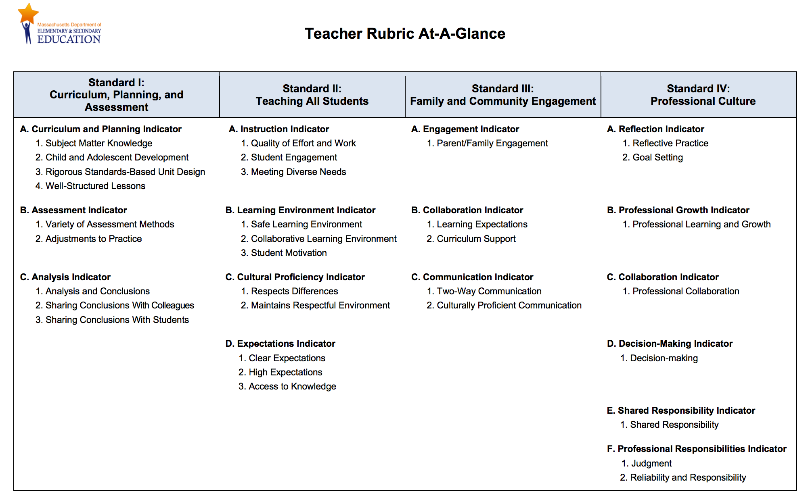

SMART Goals

S = Specific and Strategic
Goals need to be straightforward and clearly written, with sufficient specificity to determine whether they have been achieved. A goal is strategic when it serves an important purpose of the school or district as a whole and when it addresses something that is likely to have a large impact on the overall vision.

M = Measurable
If it cannot be measured, it cannot be managed. What measures of quantity, quality, and/or impact will be used to determine whether the goal has been achieved? How will progress along the way be measured? Progress toward achieving the goal typically is measured through benchmarks. Some benchmarks focus on the process, as in are we doing what we said we were going to do? Other benchmarks focus on the outcome, as in are we seeing early signs of progress toward the results?

A = Action Oriented
Goals have active, not passive verbs. The action steps attached to the goals indicate who is doing what. Without clarity about what is actually going to be done to achieve the goal, a goal is only a hope with little chance of being achieved. Making clear the key actions required to achieve a goal helps everyone see how their part of the work is connected to other parts of the work and to a larger purpose. This knowledge helps people stay focused and energized rather than become fragmented and uncertain.

R = Rigorous, Realistic, and Results Focused (the 3 Rs)
A goal is not an activity—a goal makes clear what will be different as a result of achieving the goal. A goal needs to describe a realistic yet ambitious result. It needs to stretch the educator, team, school, or district toward improvement, but it should not be out of reach. The focus and effort required to achieve a rigorous but realistic goal should be challenging but not exhausting. Goals set too high are discouraging, while goals set too low will leave a feeling of emptiness when they are accomplished and will not serve students well.

T = Timed and Tracked
A goal needs to have a deadline. Deadlines help everyone take action. For a goal to be accomplished, there should be definite times when key actions will be completed and benchmarks will be achieved. Tracking the progress made on action steps (process benchmarks) is essential— falling behind on doing one action will result in needing to accelerate the pace on another. Tracking progress on process outcomes is not enough, however. Outcome benchmarks help educators know whether they are on track to achieve the goal and/or whether they have reached the goal. Benchmarks give educators a way to see progress and celebrate it. They also give educators information they need to make midcourse corrections.

Sample SMART Goals

By June 2014, 90% of 5th grade students will score 3 or better on the conventions rubric as evidenced by the school writing assessment rubric.
By the end of the first semester, the number of students tardy to school will decrease by 10% as measured by the iPass attendance tracker.
By May 2015, 100% of PreK-12 grade teachers will have priority benchmarks identified and
aligned for mathematics for each grade level as documented by the district's online benchmark tool.
By utilizing (approach/instructional strategy), students (AP students?) will be able to properly analyze and cite textual evidence to support a well-developed thesis that takes a position on a piece of non-fiction through close reading and our implementation of a pre- and post- common assessment, scored with a common AP-based rubric, so that 80% of the students (in certain population) will improve by one score by the end of the school year 2012-2013.
My Algebra Part 2 students will become proficient in solving systems of equations using multiple
methods and being able to apply these concepts to real world problems within a 4-6 week unit
of study. Students will show their proficiency by being able to solve problems and find solutions
to real world problems with at least 75% accuracy.
100% of the students in the school to work program will increase their score on the LCCE
knowledge battery exam (a test that measures the level of independent daily living skills) by 5% over
baseline data by 6/1/14.
In order to improve comprehension and writing (literacy) in science content, 75% of the students will
score at least one point higher on an open response according to the Science Department Open
Response rubric byJune 2013.
By the end of 2014-2015 school year, at least 90% of our students will demonstrate (x measure of improvement) in (what area of) reading comprehension based on formative and summative assessments issued on (date/frequency) in the form of (format). The teacher will (action) to support student growth.
Given pre-writing strategies, appropriate technology and a prompt, students will complete writing activities as appropriate to audience and assignment with 75% accuracy for structure, content and writing conventions in three out of five recorded opportunities.
By June of 2015 I will work with my team to complete the Junior Curriculum so it is aligned with the Common Core Standards. This goal is aligned with my departmental, school and district goals.

SMART Goals Planning Form

____Student Learning Goal | ____Professional Practice Goal
____Connection to District Strategic Plan | ____Connection to School Improvement Plan
____Connection to Teacher Evaluation Rubric | ____Connection to Team Goals

SMART Goal | Specific:  Measurable:  Action-Oriented:  Rigorous/Realistic,  Results-Focused:  Timed and Tracked:
Key Action Steps
Resources Needed
Timeline
Benchmark/
Evidence

Review Meetings

Beginning-of-Cycle Review | - Review of self-assessment  - Review and development of 2 SMART Goals  - Mutually agree upon 3-4 pieces of evidence
Mid-Cycle Review | - Educator submits evidence on progress on goals  - Assessment on progress toward attaining goals  - Assessment on performance on each standard  - Comments and Feedback for Improvement
End-of-Cycle review | - Assessment on meeting goals  - Rating on 4 Standards  - Overall Rating  - Comments and Feedback

How to Use TeachPoint

How do I log into TeachPoint?

1. Go to: www.goteachpoint.com and click on Login at top of page

2. Log-in
  - District: mursd
  - Login: first initial, last name (ex. mcohen)
  - Password: (You can either enter the password from the first time you have logged into TeachPoint. You can click on “forgot my password” to reset.)

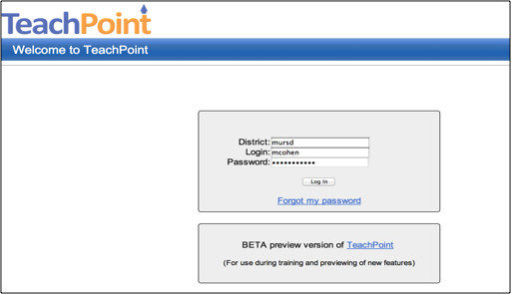

How do I create a new form?

1. Click on “New” in top menu bar and all of the available forms will appear.

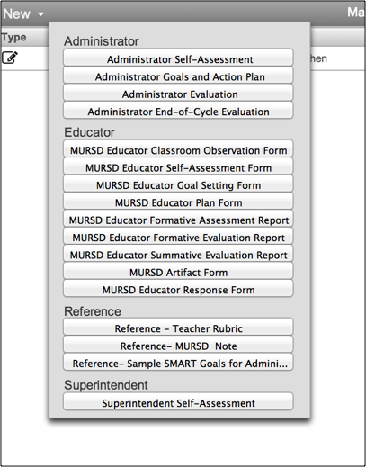

Some of the forms educators will need to use include:
  - MURSD Educator Self-Assessment Form
  - MURSD Educator Goal Setting Form
  - MURSD Educator Plan Form
  - MURSD Evidence and Reflection Form

How do I complete an Educator Self-Assessment Form in TeachPoint?

The self-assessment form is completed annually by the educator at the beginning of the evaluation cycle. The self-assessment includes an analysis of evidence of student learning, growth and achievement for students under the Educator’s responsibility. It is also an assessment of practice against each of the four Performance Standards of effective practice using the rubric below.

The educator checks the box for each element to indicate where their assessment of proficiency against the standard. Once the box is checked, it will change color (see green box below).

Blue comment boxes are available at the end of each standard for educators to elaborate in their self-assessment ratings.

Sample: 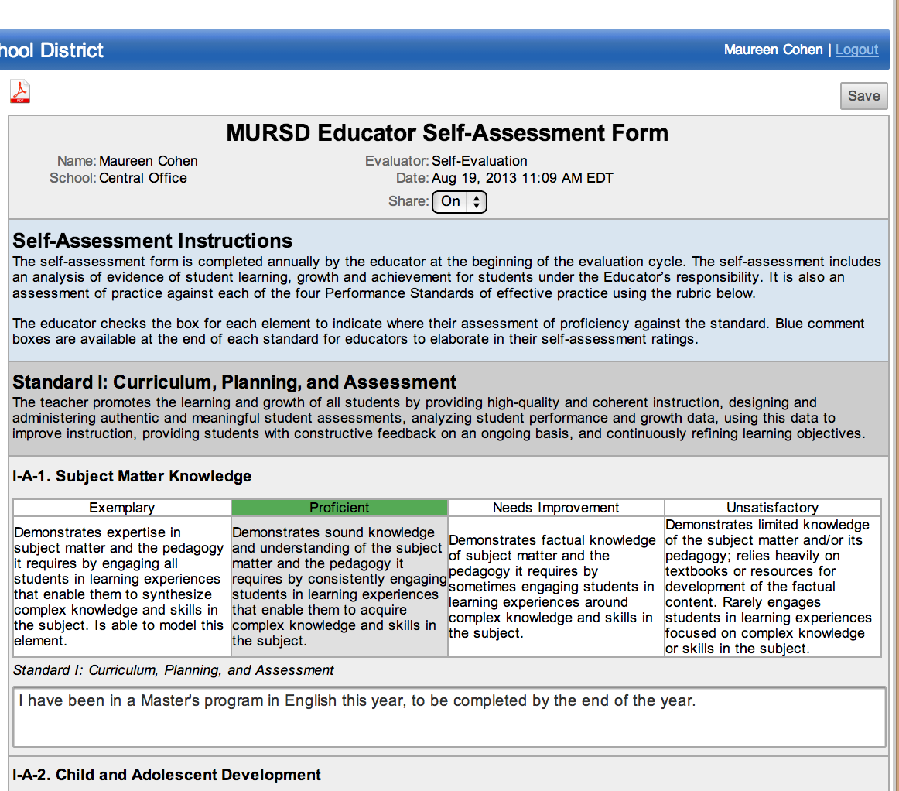

To Save the Form: In the upper right corner of the rubric is a “Save” button

To Share the Form: In the middle of the heading use the dropdown to share the form with your evaluator for them to view.

Self-Assessment Checklist Form

____ Log in to TeachPoint—create/change password

____ Complete Self-Assessment
___ Create a new form by clicking on “new” and selecting “MURSD Educator Self-Assessment
Form”
____ Click on the appropriate category (should highlight) for each element of the rubric
____ Enter notes in the boxes below the elements (where applicable)
____ Save periodically to be sure you do not lose your information
____ When complete-click share- to share with the evaluator prior to beginning-of-cycle
meeting

SMART Goal Checklist Form

____ Create Student Learning Goal (SL) ____ Create Professional Practice Goal

SL PP
____ ____ Decide whether you are working on a department/team/grade level goal or an
independent goal
____ ____ Identify your goal that is directly connected to the school improvement plan, district
strategic plan or educator evaluation rubric
_____ ____ Use the SMART goal worksheet to help you identify all the important elements of your
goal
____ ____ Write your goal making sure your goal is
S-specific and strategic
M- measurable
A-action-oriented
R-rigorous, realistic, results-oriented
T- timed and tracked
____ ____ Write the key actions that will allow you to accomplish your goal
____ ____ Write the benchmarks that provide evidence that you have completed each key action in
your goal
____ ____ Enter your goals, key actions, and benchmarks into TeachPoint
____ ____ Create new form by clicking on “new” and selecting “MURSD Educator Goal Setting Form”
____ ____ Share your SMART goal form with your primary evaluator

____ ____ Consider 3-4 pieces of evidence you might use to show achievement of your goals and growth in the performance standards outlined in the rubrics.

How do I complete the Evidence and Reflection Form ?
At the top of the MURSD Evidence and Reflection Form, write in the name of the primary evaluator, the title of the evidence you are submitting. Most importantly is the description of the evidence. Please explain in detail what the standards of educator performance the evidence illustrates. Finally, you check if it aligns to either student learning or professional practice goals, and you also check off the indicators and elements the artifact aligns to.

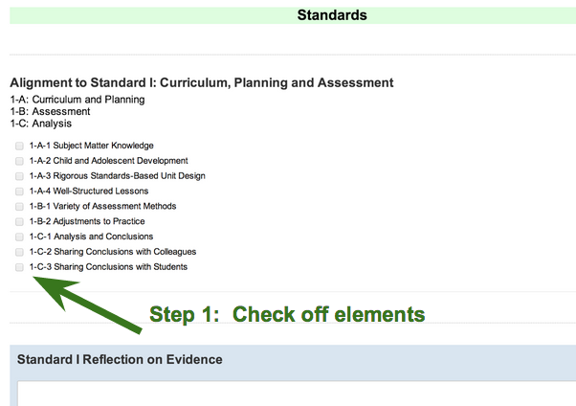

How do I upload evidence?
Evidence (documents, photos, videos, etc.) can be attached directly to a form, as well as to a specific question. When a user attaches evidence to a form you will have the option to choose if and which question the evidence belongs to, otherwise the evidence can be attached to the bottom of the form itself.
Video attachments now have the ability to click and play within the web-based version of TeachPoint. When video's are uploaded they are automatically down-converted to 480p to save space and keep the end user experience speedy. You will notice on sample artifact on the previous page, there are blue buttons that say “Add” where you can attach the evidence (documents files, photos, videos).
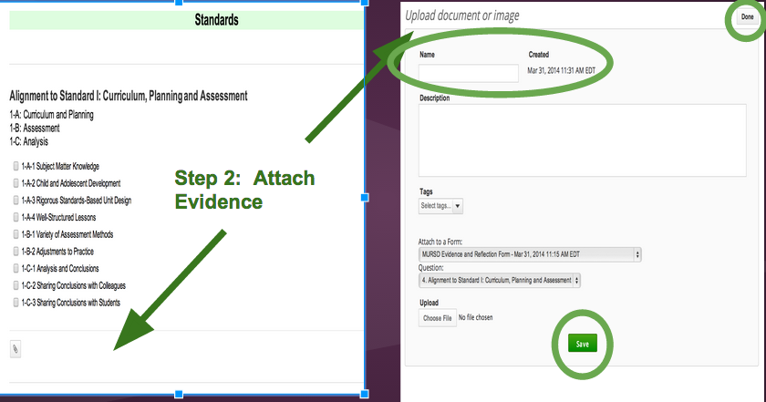

What do I need to write for a reflection?
Please put a clear description of why you chose the piece of evidence and how it relates to the standard or to your goals. This is essential for the evaluator to fully understand the evidence you are sharing.
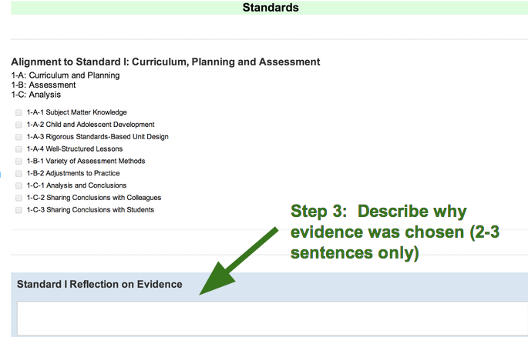
How do I organize my data and forms better?
Each column is sortable, which allows you to reorganize your information by type, name of form, who created the form or uploaded the evidence, whether it has been shared, reflected, or signed, as well as the creation date. Now that we can attach evidence directly to a form, you can see how many pieces of evidence are associated with a particular form. Also available in the bottom left is a search and filter screen to find or sort specific forms, videos, documents and images.

By default the forms screen will display the current year's data, but with a quick switch in the top right each user can choose whether to display current year, last year, last two years, all data, or a custom data range.
Sortable Columns, Searching by name, Filter by type, Filter by Year.
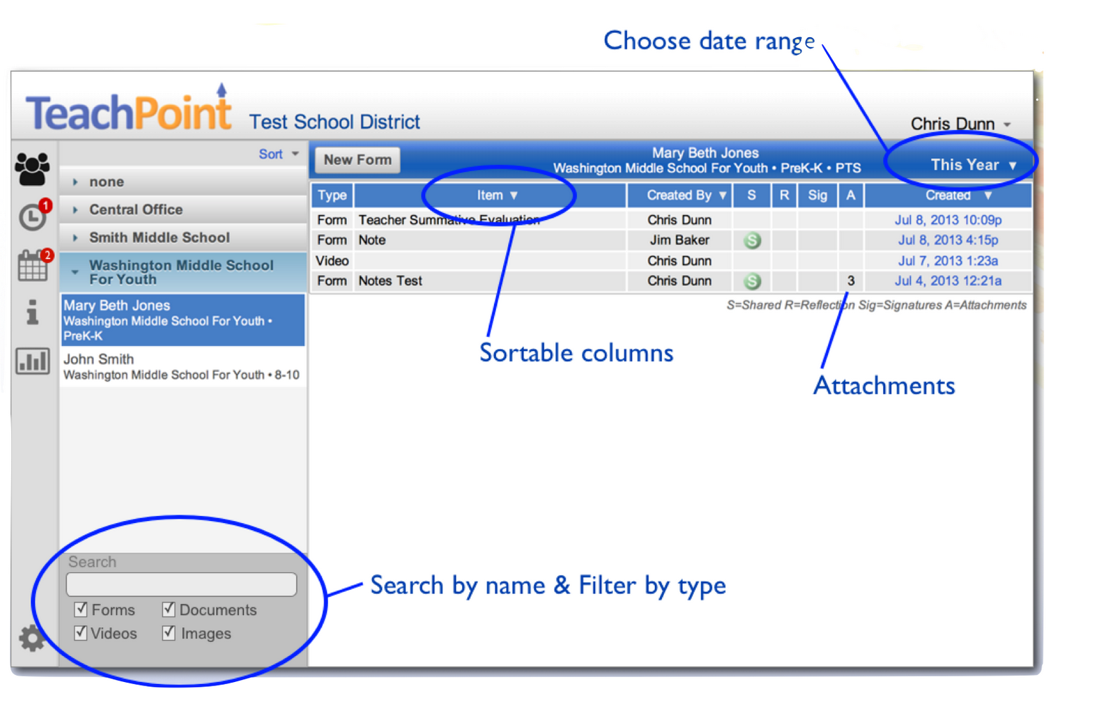
Notifications of new forms
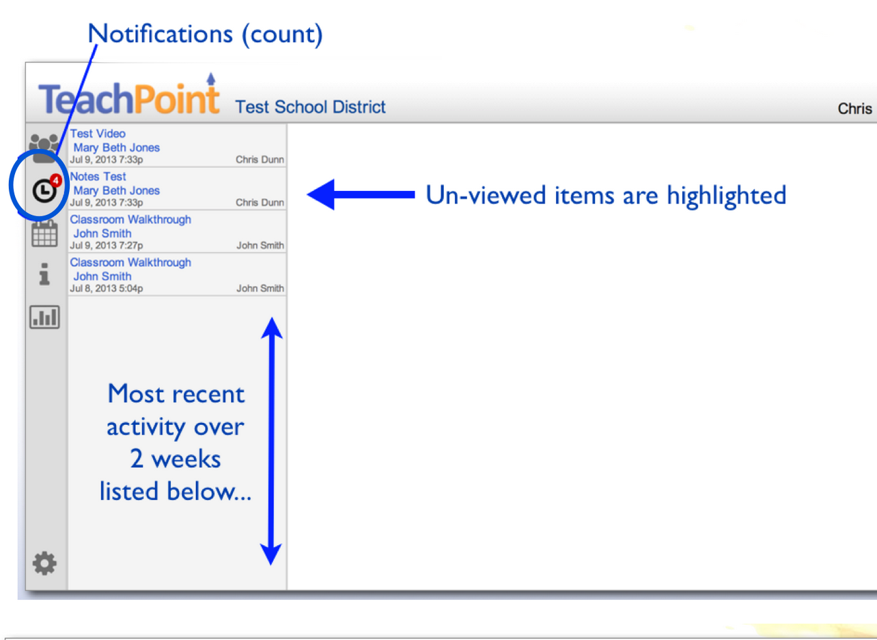

Key Points to Consider When Thinking about Evidence:

Everyone is required to collect artifacts that show evidence of their 1) goals and 2) their practice as aligned to the Standards and Indicators of the Educator Rubric.

- Evidence should be clearly tied to educator goals, indicators and elements.

- Evidence selection should be strategic. Think about what type of evidence might tell a story (lesson plan, results from formative assessments, student work samples, revised lesson plan to show how practice as adjusted based on student data). Or think about how one piece of evidence can show examples of practice associated with multiple Standards and Indicators.

- Ask yourself if the evidence or groups of evidence shows what you want it to demonstrate?

- Remember that evidence should be naturally occurring products of practice and not something produced just for the sake of evaluation.

- The district’s expectation is that there will be only 3-4 comprehensive and strategic pieces of evidence provided to the evaluator.

Sample Evidence for Educator Evaluation

Standard I: Curriculum, Planning and Assessment
- Unit and lesson plans with curriculum alignment/objectives/assessments outlined
- Classroom webpage with lesson plans, homework, expectations
- Meaningful integration of technology as evident in lesson plan/video submittal
- Classroom observations of checks for understanding and formative assessments
- Feedback on learning to students
- Analysis of formative assessments or exit ticket data

Standard II: Teaching All Students
- Lesson plans that illustrate differentiated learning opportunities
- Learning activities that have been modified for special education needs
- Classroom observations of differentiated activities
- Integration of “total participation techniques” that actively engage all students in the lesson (lesson plan)
- Student work submittal illustrates high expectations and alignment to standards

Standard III: Family and Community Engagement
- Notes from parent meetings
- Copies of email exchanges with families
- Progress reports, daily logs, daily data sheets to parents
- Workshops inviting parents in to learn about content
- Information sent home to parents to provide them with ways to interact with content at home
- Newsletters sent home

Standard IV: Professional Culture
- Minutes from team or grade level meetings
- Presentations to the team, department, or faculty
- Minutes/agendas from collaborative curriculum work
- Participation in mentoring program
- Peer observations
- Data analysis results from collaborative team work

MURSD High Leverage Elements

The MURSD team unpacked the educator evaluator rubrics in the 2012-2013 school year and identified seven high leverage elements. The highlights from these conversations are identified in the following section.

Element I-A-1 Subject Matter/Knowledge
Demonstrates sound knowledge and understanding of the subject matter and the pedagogy it requires by consistently engaging students in learning experiences that enable them to acquire complex knowledge and skills in the subject.

What does this look like in practice?

Variety of instructional activities: (use of technology, PowerPoints, Smartboard, manipulatives, small groups) | Critical thinking, reflective thinking, and problem solving activities are evident | A well-structured lesson (adapted many learning styles, multi-modal/current research, whole class-small group-independent (varies), modeling, collaboration)
Teacher asks questions that lead to and facilitate a high level of discussion and synthesis. Questions are open-ended. | Content and instruction are scaffolded and make connections. | Students are engaged and asking questions that relate to the content.
The learning objectives are tied to the standards, communicated and the students are able to understand them. | Student-centered learning (discussion, problem-solving, application of knowledge) | The teacher is “highly qualified” and has appropriate degree and license and is pursuing further studies.
Learning activities are differentiated, offer choice, and fit with student needs. | Accountability: students are progressing on given standards; unit tests, group check-ins, guided questions. | Integration of meaningful hands-on activities and manipulatives.
Integration of technology to enhance student understanding and application | Strategic grouping of students for collaborative work | Teacher check-in of student learning through various checks for understanding

Element I-A-4: Well-Structured Lessons
Develops well-structured lessons with challenging, measurable objectives and appropriate student engagement strategies, pacing, sequence, activities, materials, resources, technologies, and grouping.

What does this look like in practice?
Lessons are sequenced (beginning-middle-end) and scaffolded (gradual lead up to objective) | Informal formative assessments multiple times throughout the lesson | Time on learning is maximized with little down time and quick transitions.
Each lesson provides a variety of learning experiences that address higher levels of thinking. | Varied models of instruction (whole group, independent, and cooperative learning) | All students are given opportunities to participate in the learning activities.
Learning objectives are aligned to the common core and clearly communicated to the students in a kid-friendly way. | Lessons incorporate many student-centered and student-directed opportunities for practice and learning | Opportunities are built-in the lesson for student discussion
Technology resources are integrated into the lesson to enhance student access to information and engagement. | Groups are well-balanced, heterogeneous in terms of skill-set, willingness to participate, gender, etc. | Learning expectations are challenging, but not overwhelming
There are a variety of classroom activities: lab, video, think-pair-share, presentations, hands-on, group work, technology | Various ways of developing and presenting concepts and lessons using a multi-modal approach | Movement and interaction: student, student/student, teacher, etc.

Element I-B-2: Adjustment to Practice
Organizes and analyzes results from a variety of assessments to determine progress toward intended outcomes and uses these findings to adjust practice and identify and/or implement appropriate differentiated interventions and enhancements for students.

What does this look like in practice?
Re-teach lessons implemented and re-assessment data tracked | Teacher Self-Reflection and modification of practice | Differentiated assessments
Use and analysis of a variety of assessments in a data binder (SRI, SMI, Running Records, IXL, Pre-post tests) | Develop enrichment opportunities to challenge and extend learning for advanced students. | Use pre-test and post-test.
Tracking student academic growth | Team analysis of assessments and revision to curriculum. | Frequent checks for student understanding
Incorporating project based learning. | Portfolios. | Response to Intervention for individuals/small group weaknesses.
Set goals and check in on them | Data is made public to students through classroom displays | Prompt, actionable, appropriate and specific feedback

Element II-A-1 Quality of Effort and Work
Organizes and analyzes results from a variety of assessments to determine progress toward intended outcomes and uses these findings to adjust practice and identify and/or implement appropriate differentiated interventions and enhancements for students.

What does this look like in practice?
Students taught to self-evaluate using rubrics and portfolio process | Sharing exemplars of writing examples, projects | Guided practice through graphic organizers, step by step checklist, collaborative practice, conferencing
Rubrics: clearly defined expectations | State/post objective using visual/auditory expectations and alignment to the standards | Quality vs. quantity. Depth of understanding.
Student conferences to help student growth and understanding | Incorporate student errors into the lesson | Setting a tone of hard work and high expectations. A message that “this work is important.”
Multi-sensory instruction | Discussions with students about what quality work looks like | Clearly communicate high expectations to parents and guardians
Exit strategies that reinforce expectations | Evaluate and monitor progress throughout all steps in an assignment or project. | Peer teaching/critiquing

Element III-B-2 Curriculum Support
Regularly updates parents on curriculum throughout the year and suggests strategies for supporting learning at school and home, including appropriate adaptation for students with disabilities or limited English proficiency.

What does this look like in practice?
Monthly newsletter to parents | Daily data charts (home/school) | Moodle/Learning platform
Parent Nights/Workshops offered on content skills | Daily logs/home logs | Social Media (Facebook/Twitter/Blogs)
Open House/Conferences | E-mail updates | Classroom webpages updated with syllabus, study guides homework,
Progress Reports/Report Cards | Notebook checks | Missed homework slips/ While you were out sheets
iParent postings | Parent phone calls | Reminder flyers home

Element IV-C-1 Professional Collaboration
Consistently and effectively collaborates with colleagues in such work as developing standards-based units, examining student work, analyzing student performance, and planning appropriate intervention.

What does this look like in practice?
MCAS Analysis | Child Study/RTI/SET/IEP | Student work samples to be analyzed as a group
Use of prep time to plan units together | Common Assessment planning and analysis | Utilizing common planning time and grade level meetings
Creating interdisciplinary units | Peer observation of classrooms | Collaborative and co-teaching models
Developing standards based units | Collaboration during professional development time | Curriculum meetings to discuss classroom activities, goals, assessments
Common Core alignment of curriculum | Vertical and horizontal alignment of curriculum | Collaboration between classroom teachers and specialists

Element IV-F-2 Reliability and Responsibility
Consistently fulfills professional responsibilities; is consistently punctual and reliable with paperwork, duties, and assignments; and is rarely late or absent from school.

What does this look like in practice?
Fully engaged in profession and understand expectations. Acts professionally. | Arrive at meetings prepared with appropriate paperwork | Excellent attendance and arrives on time.
Lessons planned out ahead | Communicate in a timely manner | Corrects homework and assignments in a timely fashion
Arrives at assigned duties on time and is an active participant in duty responsibilities | Reads professional literature and acquires background knowledge in content and grade level areas | Furthers own learning through attendance in workshops, conferences, and other professional development
Completes paperwork for Student Support Services completely and in a timely manner | Is an active, positive, and collaborative participant in staff meetings, PD days, grade level and dept meetings. | If absence, leaves quality plans in absence/sub folder

